**Industrial Internship Report on**

**” Street light Monitoring System**

**With distance senser ”**

**Prepared by**

**[Ravi kumar]**

|  |
| --- |
| *Executive Summary* |
| This report provides details of the Industrial Internship provided by upskill Campus and The IoT Academy in collaboration with Industrial Partner UniConverge Technologies Pvt Ltd (UCT).  This internship was focused on a project/problem statement provided by UCT. We had to finish the project including the report in 6 weeks’ time.  My project was (to monitor the status of streetlights remotely and manage them efficiently.)  This internship gave me a very good opportunity to get exposure to Industrial problems and design/implement solution for that. It was an overall great experience to have this internship. |

**TABLE OF CONTENTS**

1 Preface 3

2 Introduction 6

2.1 About UniConverge Technologies Pvt Ltd 6

2.2 About upskill Campus 10

2.3 Objective 12

2.4 Reference 12

2.5 Glossary 13

3 Problem Statement 14

4 Existing and Proposed solution 15

5 Proposed Design/ Model 17

5.1 High Level Diagram (if applicable) 18

5.2 Low Level Diagram (if applicable) 19

5.3 Interfaces (if applicable) 19

6 Performance Test 21

6.1 Test Plan/ Test Cases 21

6.2 Test Procedure 21

6.3 Performance Outcome 21

7 My learnings 21

8 Future work scope 23

# Preface

**Summary of the whole 6 weeks’ work.**

Creating a streetlight monitoring system in Android involves combining various technologies, such as Android app development, IoT (Internet of Things) devices, and communication protocols. The goal is to monitor the status of streetlights remotely and manage them efficiently. Below is a high-level outline of the steps involved in creating such a system:

1. Hardware setup:

Install IoT devices (like sensors or microcontrollers) on each streetlight. These devices should be capable of detecting the status of the streetlight (on/off), collecting data, and communicating with the Android app through the internet for that I used Arduino uno and ultra sensor for my project.

2.Server setup:

Set up a cloud server to collect and store data from the IoT devices. The server should be able to handle incoming data from streetlights LED and store them in a database for that I used firebase setup.

3. Android App Development:

Now Developing an Android app that serves as the user interface for the monitoring system. Users should be able to see the status of each streetlight and control them remotely.

4. Real-time Data Retrieval:

Here, I am Configure the Android app to subscribe to the Arduino uno codes where the IoT devices publish their status data. This way, the app can receive real-time updates about the streetlight LED as well as Distance sensor statuses.

5. Status Display:

Then I have design the app interface to display the status of each streetlight LED (on/off) with different colors button for easy visualization and Distance reading status.

6. Remote Control:

Now Implemented a features in the Android app that allow users to remotely control the streetlight LED This could include turning them on/off.

7. Testing and Deployment:

Thoroughly test the Android app and ensure that the communication between the app, server, and IoT devices is seamless. After testing, deploy the app on the Google Play Store or distribute it to the target users.

At last, ensuring that the communication between the Android app and the server is encrypted, and user data is protected. Additionally, checking for scalability to handle a growing number of streetlights and users in the future.

**About need of relevant Internship in career development.**

An Android internship plays a crucial role in career development by offering hands-on experience and practical knowledge in mobile app development. Through internships, aspiring developers gain exposure to real-world projects, industry best practices, and teamwork. It provides an opportunity to work under experienced mentors, enhancing technical skills and fostering creativity. Android internships empower individuals to build a strong foundation for a successful career in the ever-evolving mobile technology landscape.

**Brief about Your project/problem statement.**

The Android implementation summary of the "Street Light Monitoring System" with a distance sensor would involve developing a mobile application that interacts with the distance sensor and provides control and monitoring functionalities for the street lights.

**Opportunity given by USC/UCT.**

It was a great opportunity for me as Android development intern in a versatile and dynamic field, The development process would involve collaboration between Android app developers, sensor experts, and system integrators to create a robust and effective solution.

**How Program was planned**



**Your Learnings and overall experience.**

It was a great opportunity for me as Android development is a versatile and dynamic field, Thank you for offering opportunities to create innovative mobile applications that cater to diverse my needs and enhance the overall my experience

Thanks to all (my teacher and mentor Saumya Singh, Joyti ma’am), who have helped you directly or indirectly.

Dear juniors and peers,

I wanted to share my experience with you regarding my Android development internship. It has been an incredible journey that has enriched my skills and opened up numerous opportunities in the tech industry. During the internship, I gained practical knowledge, worked on real projects, and collaborated with experienced mentors, which significantly boosted my confidence and expertise in Android development.

I highly encourage all of you to consider pursuing an Android internship. It will be an invaluable experience that will not only enhance your technical abilities but also provide a solid foundation for a successful career in the mobile app development field. Embrace the challenges, stay curious, and never stop learning. Together, let's make the most of this exciting and ever-evolving world of Android development!

Best wishes,

Ravi Kumar

# Introduction

## About UniConverge Technologies Pvt Ltd

A company established in 2013 and working in Digital Transformation domain and providing Industrial solutions with prime focus on sustainability and RoI.

For developing its products and solutions it is leveraging various**Cutting Edge Technologies e.g. Internet of Things (IoT), Cyber Security, Cloud computing (AWS, Azure), Machine Learning, Communication Technologies (4G/5G/LoRaWAN), Java Full Stack, Python, Front end**etc.



1. UCT IoT Platform **(****)**

**UCT Insight** is an IOT platform designed for quick deployment of IOT applications on the same time providing valuable “insight” for your process/business. It has been built in Java for backend and ReactJS for Front end. It has support for MySQL and various NoSql Databases.

* It enables device connectivity via industry standard IoT protocols - MQTT, CoAP, HTTP, Modbus TCP, OPC UA
* It supports both cloud and on-premises deployments.

It has features to  
• Build Your own dashboard  
• Analytics and Reporting  
• Alert and Notification  
• Integration with third party application(Power BI, SAP, ERP)  
• Rule Engine

 

1. **Smart Factory Platform (****)**

Factory watch is a platform for smart factory needs.

It provides Users/ Factory

* with a scalable solution for their Production and asset monitoring
* OEE and predictive maintenance solution scaling up to digital twin for your assets.
* to unleased the true potential of the data that their machines are generating and helps to identify the KPIs and also improve them.
* A modular architecture that allows users to choose the service that they what to start and then can scale to more complex solutions as per their demands.

Its unique SaaS model helps users to save time, cost and money.

 

1.  based Solution

UCT is one of the early adopters of LoRAWAN teschnology and providing solution in Agritech, Smart cities, Industrial Monitoring, Smart Street Light, Smart Water/ Gas/ Electricity metering solutions etc.

1. Predictive Maintenance

UCT is providing Industrial Machine health monitoring and Predictive maintenance solution leveraging Embedded system, Industrial IoT and Machine Learning Technologies by finding Remaining useful life time of various Machines used in production process.



## About upskill Campus (USC)

upskill Campus along with The IoT Academy and in association with Uniconverge technologies has facilitated the smooth execution of the complete internship process.

USC is a career development platform that delivers **personalized executive coaching** in a more affordable, scalable and measurable way.



Seeing need of upskilling in self paced manner along-with additional support services e.g. Internship, projects, interaction with Industry experts, Career growth Services

<https://www.upskillcampus.com/>

upSkill Campus aiming to upskill 1 million learners in next 5 year



## The IoT Academy

The IoT academy is EdTech Division of UCT that is running long executive certification programs in collaboration with EICT Academy, IITK, IITR and IITG in multiple domains.

## Objectives of this Internship program

The objective for this internship program was to

 ☛ get practical experience of working in the industry.

 ☛ to solve real world problems.

 ☛ to have improved job prospects.

 ☛ to have Improved understanding of our field and its applications.

 ☛ to have Personal growth like better communication and problem solving.

## Reference

* <https://developer.android.com/studio>
* https://developer.android.com/
* <https://www.geeksforgeeks.org/>
* https://www.upskillcampus.com/

## Glossary

|  |  |
| --- | --- |
| Terms | Acronym |
| UCT | Uni converge Technologies |
| EICT | Electronic and Information Communication Technology. |
| IITK | Indian Institute of Technology Kanpur |
| IITR | Indian Institute of Technology Roorkee |
| IITG | Indian Institute of Technology Guwahati |

# Problem Statement

In the assigned problem statement

The problem statement mentions a "Street Light Monitoring System" with a distance sensor. This system is likely designed to monitor and control street lights in a more efficient and automated manner.

The system's purpose might be to adjust the lighting intensity or timing of the street lights based on the data collected from the distance sensor. For instance, if the distance sensor detects no activity or traffic in a certain area, the system might dim or turn off the street lights to save energy. Conversely, when the distance sensor detects activity, it could increase the brightness or turn on additional lights to ensure adequate visibility and safety.

**Develop a project related to the Street Light Monitoring System in form of Android Application.**

# Existing and Proposed solution

To develop a project of **smart street light IOT device**, you will need to:

* Choose an IOT platform. There are many different IOT platforms available, each with its own strengths and weaknesses. Some popular platforms include AWS IOT, Azure IOT Suite, and Google Cloud IOT Core. These platforms provide secure, reliable, and scalable connectivity for IOT devices. They also offer a variety of features for building, deploying, and managing IOT solutions.
* Design the system architecture. This includes determining how the different components of the system will communicate with each other. The system architecture should be designed to be scalable, reliable, and secure.
* Develop the hardware. This includes the street light itself, as well as any sensors or actuators that you will be using. The street light will need to have a way to connect to the internet, and it will need to be able to receive and send data. The sensors and actuators will need to be able to collect data from the environment and control the street light accordingly.
* Integration of MQTT and LORAWAN. MQTT is a lightweight messaging protocol that is often used for machine-to-machine (M2M) communication. LORAWAN is a low-power wide-area network (LPWAN) technology that is designed for long-range communications with low power consumption. By integrating MQTT and LORAWAN, you can create a system that can collect data from sensors and send it to the cloud.
* Develop the mobile app. The mobile app will allow users to control the street light remotely. It will need to be able to connect to the IOT platform and send commands to the street light. It will also need to display data from the sensors.
* Deploy your system. Once you have developed all of the components of your system, you will need to deploy it. This includes setting up the IOT platform, deploying the hardware, and deploying the mobile app.

The server/cloud will be used to store data, process data, and send data to the mobile app. The server/cloud can also be used to control the street light remotely.

Here are some additional details about the integration of MQTT and LORAWAN:

* MQTT is a Publish/subscribe messaging protocol that is ideal for IOT applications because it is lightweight and efficient.
* LORAWAN is a low-power wide-area network (LPWAN) technology that is designed for long-range communications with low power consumption.
* By integrating MQTT and LORAWAN, you can create a system that can collect data from sensors and send it to the cloud.
* The cloud can then use the data to generate reports, identify problems, and track energy usage patterns.

**Required Functionalities:**

* Provide users with the ability to control the street light in a variety of ways. This could include turning the light on and off,.
* Allow users to view data from the sensors. This could include data on distance.

**Software Required**:-

The software you may use in building the project is mentioned below:-

* Mobile front-end: Swift (for iOS), Java (for Android), React Native, Flutter
* Back end: Node.js , Python , Java
* Database Technologies: Use a cloud-based database
* External Service/API Integration: Weather APIs, Water Quality APIs, IOT device APIs if needed.
* Data Visualization Libraries: ECharts , High charts ,Google Charts.

The control streetlight page is a valuable tool for anyone who wants to manage their streetlights and save energy.

## Code submission (Github link)

https://github.com/ravi1310kumar/upskill_campus

## Report submission (Github link) :

<https://github.com/ravi1310kumar/upskill_campus>

# Proposed Design/ Model

1. Street Light Monitoring System: This refers to an overall system that monitors and controls street lights. It could include various sensors, control units, and communication modules to achieve its objectives.
2. Distance Sensor: The system incorporates a distance sensor. This type of sensor is used to measure the distance of objects or obstacles in its vicinity. In the context of the Street Light Monitoring System, the distance sensor could be utilized to detect the presence of vehicles, pedestrians, or any other objects in the proximity of the street lights.

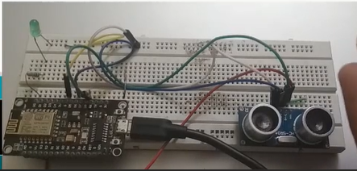

Arduino uno

Off LED

Ultra sensor

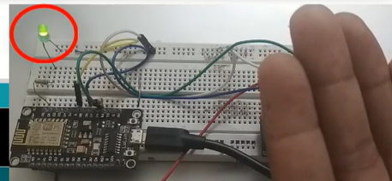

On LED

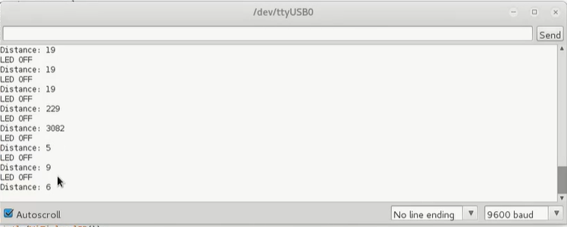

## High Level Diagram (if applicable)

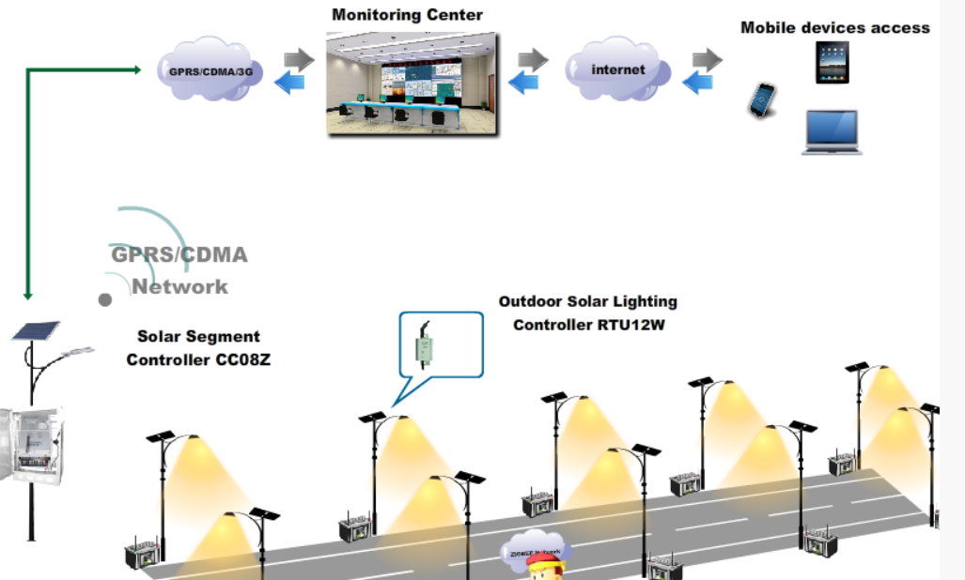

Figure 1: HIGH LEVEL DIAGRAM OF THE SYSTEM

## Low Level Diagram (if applicable)

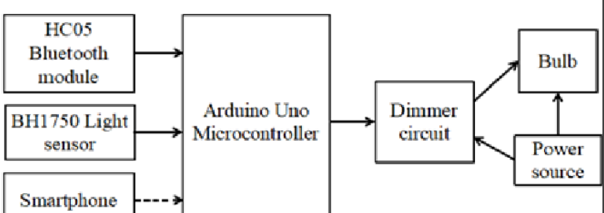

## Interfaces (if applicable)

Update with Block Diagrams, Data flow, protocols, FLOW Charts, State Machines, Memory Buffer Management.

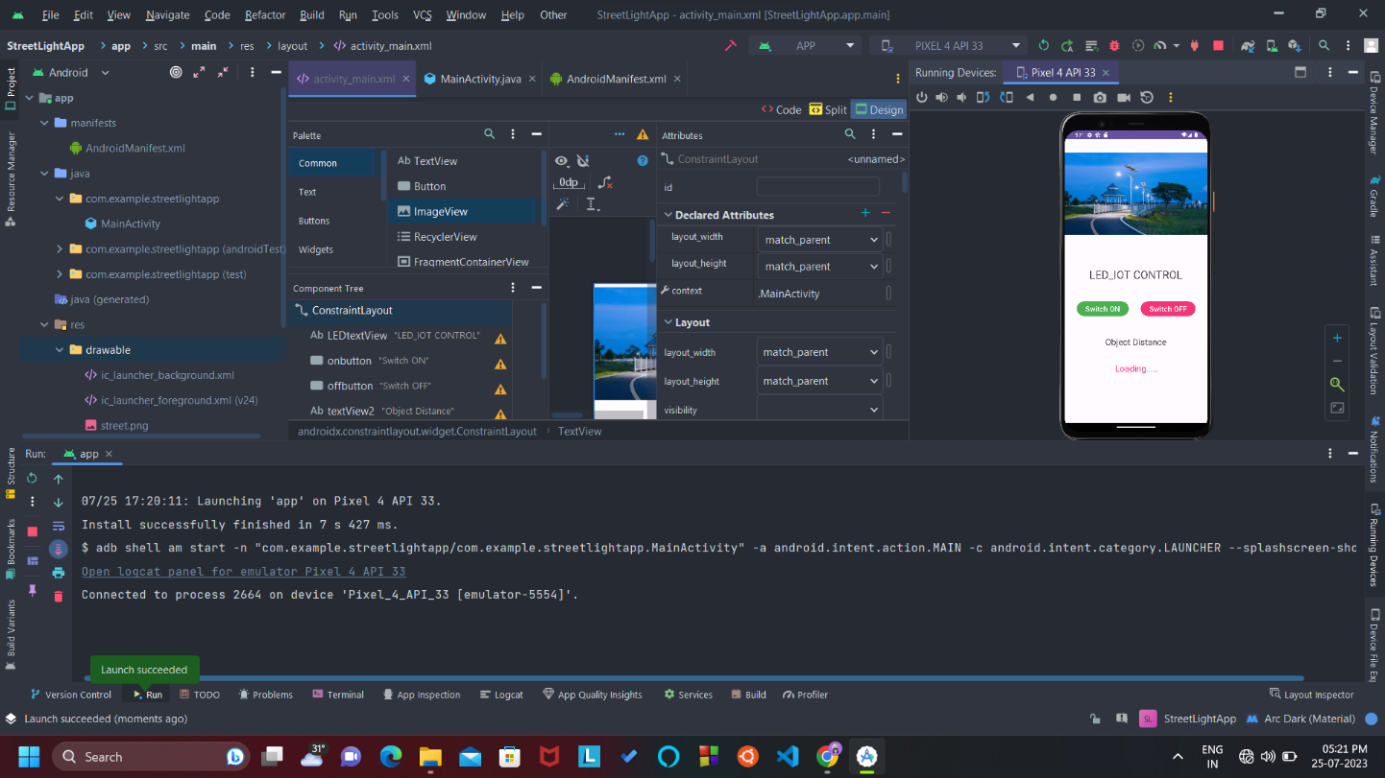

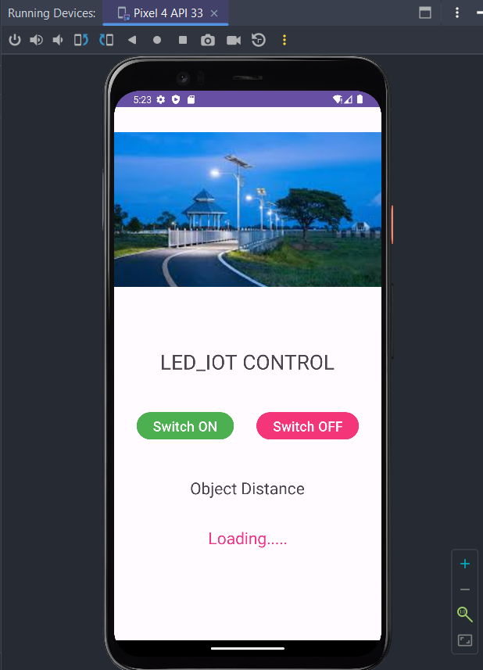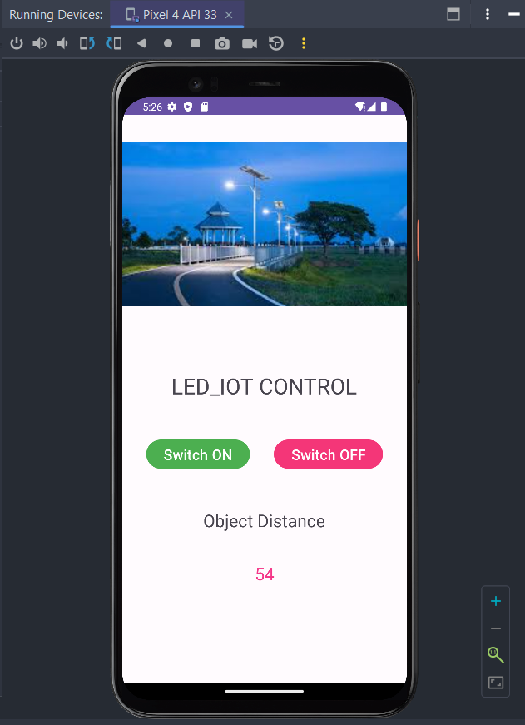

# Performance Test

This is very important part and defines why this work is meant of Real industries, instead of being just academic project.

Here we need to first find the constraints.

How those constraints were taken care in your design?

What were test results around those constraints?

Constraints can be e.g. memory, MIPS (speed, operations per second), accuracy, durability, power consumption etc.

In case you could not test them, but still you should mention how identified constraints can impact your design, and what are recommendations to handle them.

## Test Plan/ Test Cases

## Test Procedure

## Performance Outcome

# My learnings

From the description of the "Street Light Monitoring System" with a distance sensor, there are several key learnings that can be drawn:

Internet of Things (IoT) Applications:

The project highlights the application of IoT principles in real-world scenarios. By using sensors like distance sensors, the street light system can collect data and make intelligent decisions to optimize street light operations.

Energy Efficiency:

Implementing distance sensors can lead to energy-efficient solutions. By dimming or turning off street lights when there is no activity or traffic, energy consumption can be reduced, resulting in cost savings and a positive environmental impact.

Automation and Control:

The project involves automation and control systems that can adjust street lighting based on real-time data. Automation allows for more efficient and accurate responses to changing conditions, reducing the need for manual intervention.

Safety and Public Services:

Street lighting is crucial for public safety and security. By monitoring the environment with distance sensors, the system can ensure that appropriate lighting levels are maintained to enhance pedestrian and vehicular safety.

Data-Driven Decision Making:

The project demonstrates the significance of data-driven decision making. Analyzing data from the distance sensor allows the system to respond dynamically to different situations, making it more adaptive and responsive.

Interdisciplinary Nature of Projects:

A project like this involves multiple disciplines, including electronics, sensors, data analysis, software development, and communication protocols. Collaborating across these disciplines is essential for successful project implementation.

Environmental Impact: By reducing energy consumption through better lighting management, the project contributes to minimizing the environmental footprint. This showcases how technology can play a role in sustainability efforts.

Real-World Application:

The project is an example of a practical application of technology in everyday life. It illustrates how innovations can be utilized to improve existing systems and infrastructure.

Challenges and Limitations:

While distance sensors can offer many benefits, there might be challenges such as sensor accuracy, data interpretation, and potential false positives/negatives. Addressing these challenges requires careful calibration and testing.

# Future work scope

Future Scope:

The project may inspire further developments and improvements in street lighting systems. For instance, integrating additional sensors like motion sensors or cameras could enhance the system's capabilities for even better monitoring and control.

Overall, the "Street Light Monitoring System" with a distance sensor serves as a valuable example of how technology can be harnessed to create smarter, more efficient, and sustainable solutions for public infrastructure. It also emphasizes the importance of considering environmental and societal impacts in technological innovations.